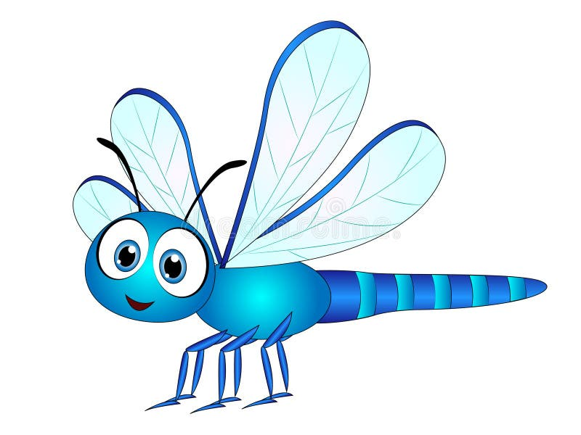
Maths

Number Begin to subitise (recognise quantities without counting) up to 5. Solve real world mathematical problems with numbers up to 5. Experiment with their own symbols and marks as well as numerals.
Numerical Patterns Count verbally beyond 10. Understand the ‘one more/one less than’ relationship between consecutive numbers to 10. Positional language: describe a familiar route, using words such as ‘in front of’ and ‘behind’. Compare numbers using appropriate vocabulary such as ‘more than’ ‘less than’, ‘equal to’. Begin to identify evens and odds to 10. Begin to recall double facts to 10. Begin to share quantities between 2 and 3 people to 10. Talk about patterns in environment and continue copy and create repeating patterns. Select, rotate and manipulate shapes in order to develop spatial reasoning skills. Compose and decompose shapes to show shapes can be made up of smaller shapes.
Understanding the World

Past and Present
Compare and contrast characters from stories including figures from the past.
People, Cultures and Communities
Understand that some places are special to members of their community. Recognise some similarities and differences between life in this country and life in other countries.
The Natural World
Begin to understand the need to respect and care for the natural environment and all living things. Understand the effects of the changing seasons on the natural world around them. Talk about what they see, using a wide range of vocabulary.

Religious Education
Christianity - Theme: Easter Key Question: What is Easter?

Communication and Language

Listening, Attention and Understanding
Engage in non-fiction books. Listen to and talk about selected non-fiction to develop a deep familiarity with new knowledge and vocabulary.

Speaking
Listen to and talk about selected fiction and non-fiction to develop a deep familiarity with new knowledge and vocabulary
Literacy

Word reading
Read a few common exception words matched to school scheme.
Read some letter groups that represent one sound.
Re-read books to build up confidence in word reading and fluency and their understanding and enjoyment.

Comprehension
Re-read these books to build up their confidence in word reading, their fluency and their understanding and enjoyment.
Writing
Write short sentences with words with known sound-letter correspondences using a capital letter and full stop.
Re-read what they have written to check that it makes sense.
The Write Stuff – Handa’s Surprise, Jack and the Jellybean Stalk, The Giant Jam Sandwich.

Little Wandle Phonics
Identifying and using tricky and high frequency words. Phonics Letters and Sounds- Phase 2/3 Identifying and using tricky words –identifying diagraphs

Expressive Arts and Design
Creating with materials – Create collaboratively sharing ideas, resources and skills. Draw with increasing complexity and detail, such as representing a face with a circle and including details. Develop storylines in their pretend play.
Being imaginative - Play instruments with increasing control to express their feelings and ideas. Listen attentively, move to and talk about music, expressing their feelings and responses. Explore and engage in music making and dance, performing solo or in groups.
Charanga Music – Listen to a range of music and join in with songs/actions including: Wind The Bobbin Up, Rock-A-Bye Baby, Five Little Monkeys, Twinkle, Twinkle, Little Star.

Personal, Social and Emotional Development (PSED)

Self-Regulation
Show resilience and perseverance in the face of challenge.
Managing Self
Shows understanding that good practices with regards to exercise, eating, sleeping and hygiene can contribute to good health.
Building Relationships
Build constructive and respectful relationships.

PSHE/RSHE – My Life
Why do we need to brush our teeth?
What are germs and how can we help to stop them spreading?
What are the different parts of my body called?
How can food help me to be healthy?
How can I keep safe in the sun?
Why do I need to move my body and exercise?
Do I understand the concept of privacy, including the right to keep things private and the right another person has to privacy?

Physical Development
Fine motor Skills
Develop the foundations of a handwriting style which is fast, accurate and efficient.
Gross Motor Skills
Know and talk about different factors that support their overall health and wellbeing; regular physical activity; healthy eating; tooth brushing; sensible amounts of screen time; good sleep routine; being a safe pedestrian.
Develop overall body strength, coordination, balance and agility needed to engage successfully with future physical education sessions and other physical disciplines including dance, gymnastics and swimming.
PE – Games Unit
To develop accuracy when throwing and practise keeping score.
To follow instructions and move safely when playing tagging games.
To learn to play again an opponent.
To play the rules and develop coordination.
To explore striking a ball and keeping score.
To work co-operatively as a team.

Half-termly Overview
Spring 2
Reception Dragonfly and Caterpillar Class 